Task Report

Create a Hash Value in Linux
We identify two files – their hash values – to compare if they are the same. Hot wings might be involved.

Task 1.
Review the contents of the two files that we are comparing

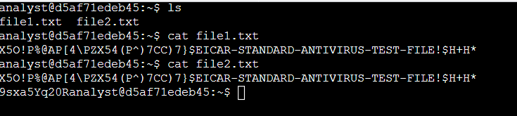

Command Semantics
    - ls this command provides a list of the files in the current working directory
    - cat file1.txt this command allows us to discover the contents of the file provided
    - cat file2.txt this command allows us to discover the contents of the file provided
    - cat <file>

Task 2.
We find that the contents of the files are the appear to be the same. We need to be sure that the files do not have hidden code that is actually different. If the code is different, in even one line, the hash will be different – potentially revealing one fo the files to have malicious code.

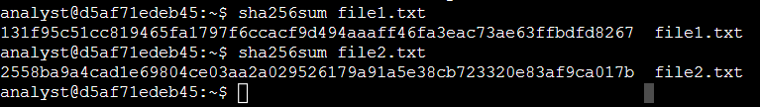

Command Semantics
    - sha256sum file1.txt This command produces a hash for “file1.txt” using the sha256 hashing algorithm. (sha = Secure Hashing Algorithm)
    - sha256sum file2.txt This command produces a hash for “file1.txt” using the sha256 hashing algorithm.

Task 3.
Now, we write the hash to a has file, then review the hash file. While in this lab, we can easily see the differences, in the following step we will use the “compare” command to show how we can use the command to find the differences.

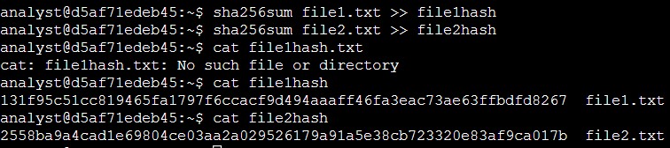

Command Semantics
    - sha256sum file1.txt >> file1hash This command hashes “file1.txt” and writes the hash to a new file – in this instance a file named “file1hash”
    - sha256sum file1.txt >> file1hash This command hashes “file2.txt” and writes the hash to a new file – in this instance a file named “file12hash”
    - cat file1hash This command shows the contents of the new file with “file1.txt”'s hash in it. This new file is nearly as great as hot wings.
    - cat file2hash This command shows the contents of the new file with “file2.txt”'s hash in it.

Task 4.
Now, we use the cmp command to compare the hash's of the two files.

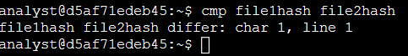

Command Semantics
    - cmp file1hash file2hash This cmp command compares the given files and outputs the first characters that differ, in this case, the 1st character of the 1st line. Not a chance.
    - cmp <file> <file>

Summary
In this lab we produced an scenario much like what a cybersecurity analyst might work through on the job. We compare two seemingly identical files, only to find that the underlying code is not actually identical. This would lead to further investigation from the Cybersecurity team to find whether or not the difference in code is the result of malicious code, which might harm our company assets. By finding this difference, we may are engaging in security posture hardening activities for our organization.
    - find the text files
    - read the text files
    - hash the text files into new files
    - compare the hashes of the two files for potential differences
    - enjoy or consider the next time one might enjoy hot wings.

